A Y O D A H

AYODAH Merchant Manual
How to list and manage your products, step by step

Edition 3 · August 2026
PT Danum Inovasi Teknologi

What is in this guide
- Before you start, have these ready
- Step 1. Apply to become a partner
- Step 2. Getting to know your dashboard
- Step 3. Listing your first product
- Step 3b. Saying what is included, and what is not
- Step 4. Write in one language; we write the other
- Step 5. What happens after you save
- Step 6. Editing or removing a product
- Step 7. Taking and completing orders
- Step 8. Cancelling an order, and refunds
- Step 9. Quoting for something that is not in your catalogue
- AYODAH fees, what is deducted
- Promotion (optional)
- Your shop and your account
- Talking to your buyers
- Rules you must know
- If you are stuck or something is wrong

Before you start, have these ready
- Photos. Landscape works best. Up to 4 MB each, in JPG, PNG or WebP. The more angles you show, the more likely somebody books.
- Your price in Rupiah. Digits only, no dots, no commas, no "Rp". For example: 450000.
- The place and the city. For example: "Borobudur Temple, Magelang" for the place, and "Yogyakarta" for the city.
- A short description. Three to five sentences about what the buyer actually gets.
- An identity number. For Indonesian merchants that is a 16-digit KTP. For other countries the app will name the document it needs.
NOTE
No photos of your own yet? That is fine. The form offers stock photos you can use for now, and you can replace them any time.

Step 1. Apply to become a partner
- Open numintek.com/ayodah-demo, then create an account or sign in.
- Tap Profile → Become a partner.
- Fill in your business name, main line of business, country, and city.
- Enter the identity number it asks for, then submit.
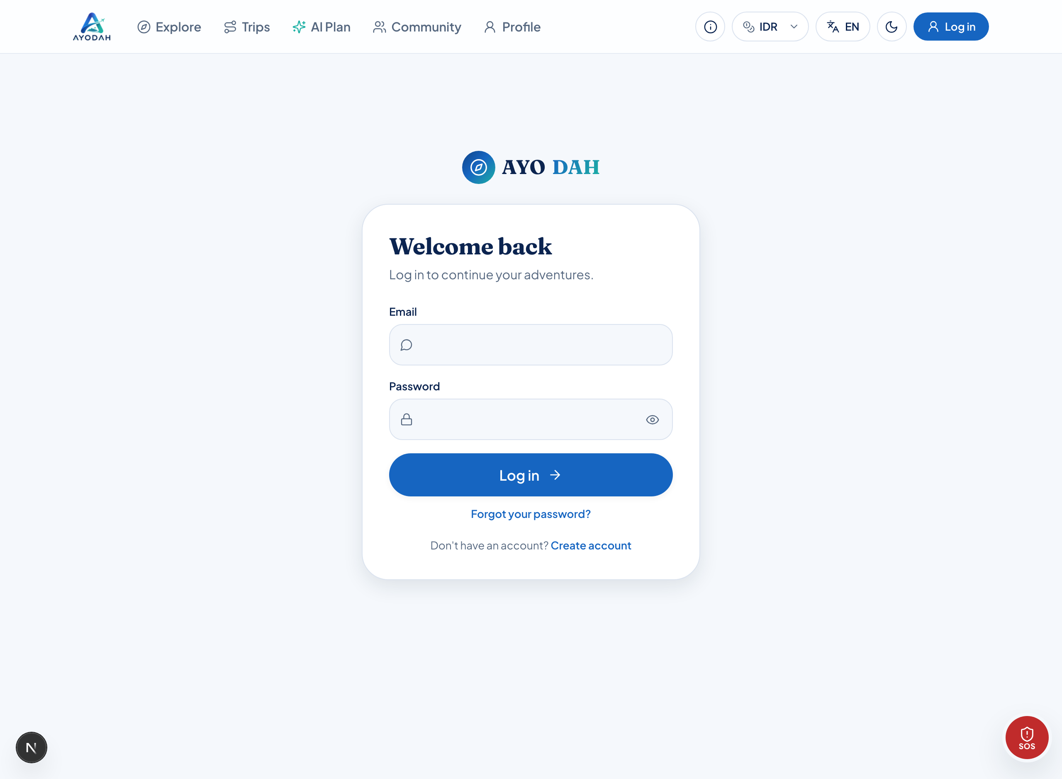
Figure 1 : The sign-in page. Enter your email and password here.
Field | What goes in it
Country | Where your business operates. This decides which identity document is asked for, an Indonesian merchant is asked for a KTP, a Thai merchant for a National ID. Travellers still come from everywhere.  Example: Indonesia
Main line of business | Pick the closest match. This is not a lock, once approved, one account can sell in any category.  Example: Tour Packages
Identity number | Stored encrypted. Never shown in full to anybody, including our own team. Only the last four digits are ever visible.  Example: 3401••••••••0002

NOTE
Approval usually takes one working day. The status shows on the same page.

Step 2. Getting to know your dashboard
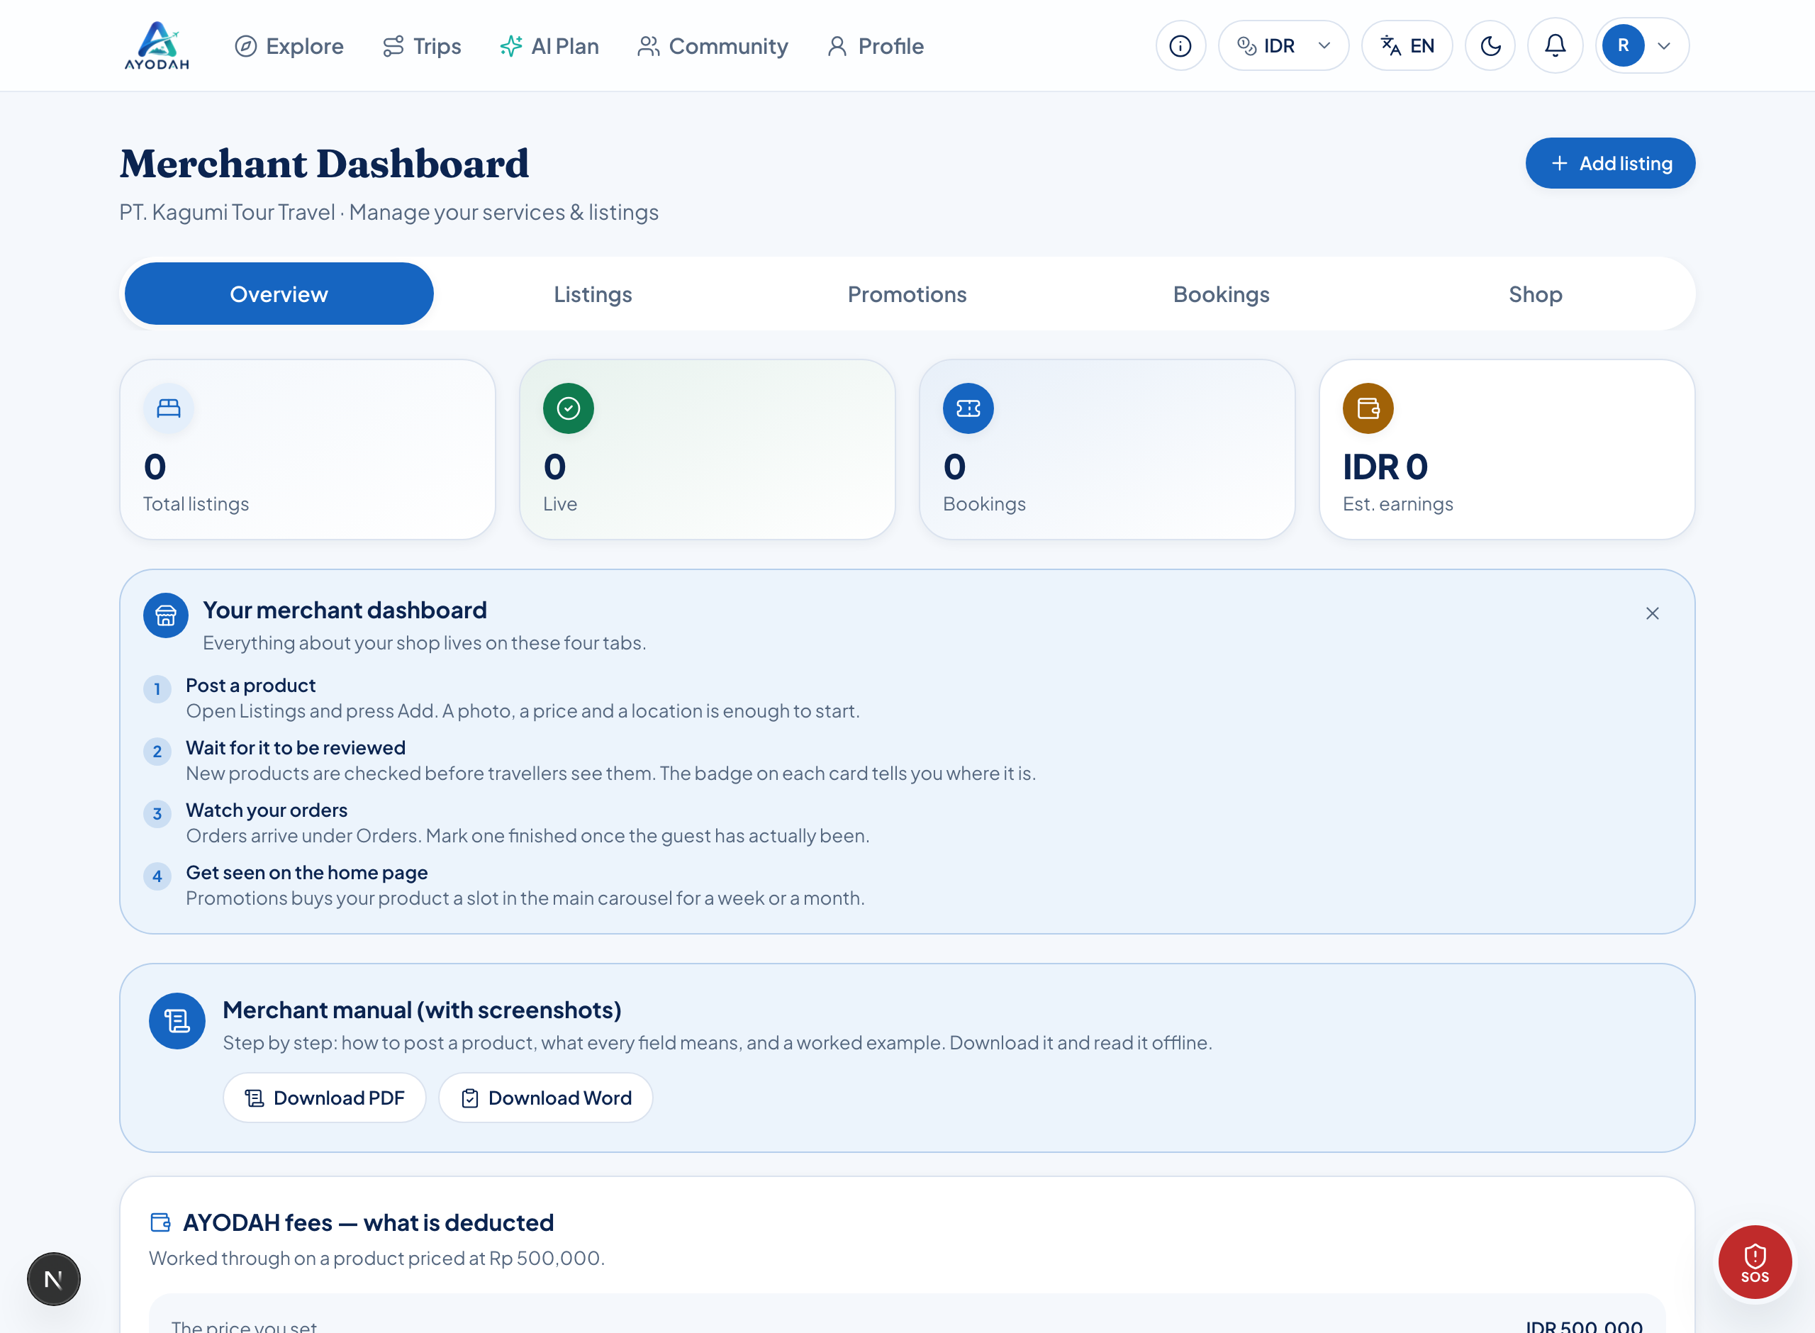
Figure 2 : The dashboard when you arrive. The figures fill in by themselves once you list something.
Tab | What is in it
Overview | Your product and order counts, estimated earnings, and a breakdown of AYODAH fees.
Listings | Your products. This is where you add a new one.
Promotions | Buy a slot so one of your products appears on the AYODAH home page.
Bookings | Orders that come in, with the buttons to mark them done or cancel them.
Shop | Your business details: name, country, city, phone, address, and verification documents.

NOTE
All zeros? That is normal for a new shop. The numbers fill in once your products are live and somebody books.

Step 3. Listing your first product
- Open the Listings tab.
- Press + Add listing at the top right.
- A form appears. Work down it from the top.
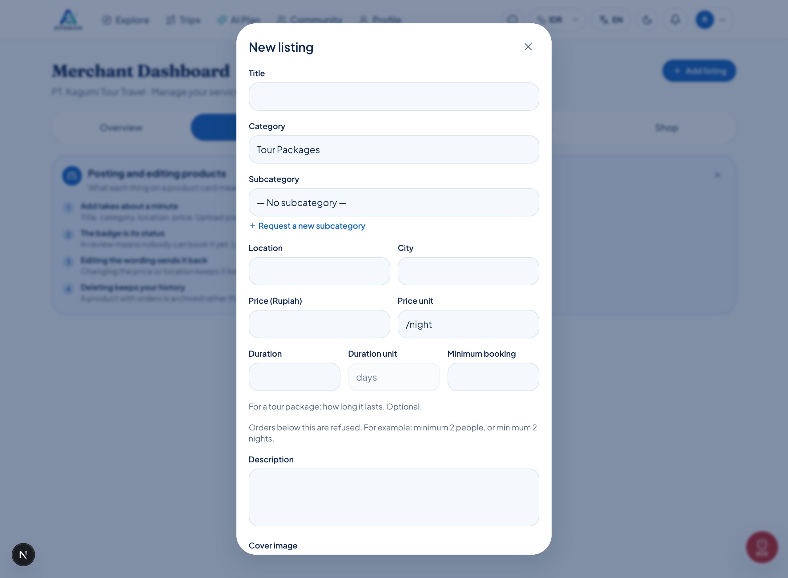
Figure 3 : The new-product form. Required: title, category, place, city, price, and a photo.
Here is what each field means, one at a time:
Field | What goes in it
Title | The name a buyer will read. Be clear and specific. Avoid ALL CAPITALS, it reads as shouting, and it gets your listing flagged for review.  Example: Borobudur Sunrise Day Tour
Category | The kind of product. One account may sell in any category, you are not locked to one.  Example: Tour Packages
Subcategory | A finer classification. You may leave it empty. If yours is missing, press "Suggest a new subcategory" and our team will add it.  Example: . No subcategory,
Place | Where it actually happens. Write the place, not the city.  Example: Borobudur Temple, Magelang
City | The city people search under. This is what a buyer filters by.  Example: Yogyakarta
Price (Rupiah) | Digits only. No dots, commas or "Rp". A price far above or below others in its category gets flagged for a look, usually that means a typo in the zeros.  Example: 450000
Price unit | What the price is for, per person, per night, or per day. Get this right: it sits next to the price on every card.  Example: /person
Duration | How long it lasts. Optional, but worth filling in for a tour package, it appears beside the price and buyers can filter on it. Do not bury it in the description any more.  Example: 3 days
Minimum booking | Orders below this are refused by the system. For example: minimum 2 people, or minimum 2 nights. Leave empty if there is no minimum.  Example: 2
Description | Say what the buyer gets: start time, what is included, and any conditions. A very short description gets flagged for review.  Example: Hotel pickup at 03:30, sunrise ticket, guide, breakfast, and drop-off before 12:00. Minimum 2 people.
Photos | Press "Upload photo", you can pick several at once. The first becomes the cover, and any of them can be made the cover without re-uploading.  Example: 3, 5 photos

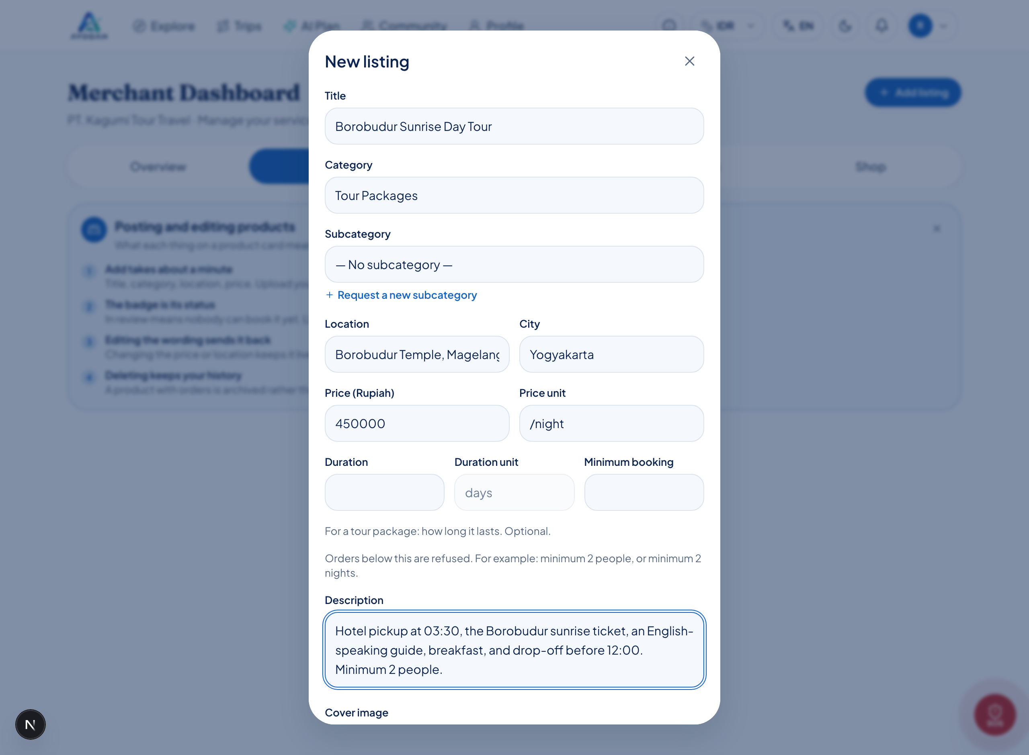
Figure 4 : A correctly filled form. Note that Place and City are different, and the price has no dots.
- Scroll to the bottom of the form.
- Press Save.
Step 3b. Saying what is included, and what is not
Under the description there are four lists. They are optional, and they are the single biggest reason a booking goes wrong: almost every complaint we see is somebody who assumed lunch was included, or turned up at the wrong gate.
List | What goes in it
Included | Everything the price covers. One line each.  Example: Hotel pickup and drop-off; Entrance ticket; Bottled water; English-speaking guide
Not included | Everything it does not, especially anything they will have to pay for on the day.  Example: Lunch; Personal expenses; Tips for the guide
Meeting point | Exactly where and when to be. Write it the way you would tell a friend who has never been.  Example: Hotel lobby, 04:30. If your hotel is outside Magelang, we agree a point the evening before.
What to bring | What the trip needs from them.  Example: Comfortable shoes; A light jacket; A copy of your passport

NOTE
These are written once and translated like the rest of your listing. Editing them does not take the product off the catalogue.

IMPORTANT
For a tour package, entrance tickets are usually bought by you, not the traveller. If your price covers them, say so under Included. If it does not, say so under Not included, and give the amount. A traveller who finds out at the gate blames the app and blames you.

Step 4. Write in one language; we write the other
Write in whatever language you think in. When you save, the system produces the other language, and buyers read your listing in theirs.
- The translation is clearly marked as machine-made, so buyers know what they are reading.
- If you correct the translation yourself, the system will never overwrite it again.
- Changing only the price does not trigger a re-translation.
NOTE
Place names, brands and numbers are left alone, "Candi Borobudur" stays "Candi Borobudur".

Step 5. What happens after you save
Every new product is screened. If nothing is found and your record is clean, it goes live immediately. If anything needs a human eye, it queues for a short while.
Label on the product | What it means
In review | Being checked. Not bookable yet. Usually cleared within one working day.
Live | Visible in the app and bookable.
Not approved | Something needs fixing. Check the title, photos and description, then save again.
Archived | You deleted it, but it had orders, so we keep the record.

Once a few of your products have been approved, later ones usually go live without queuing. Trust is built from your record.
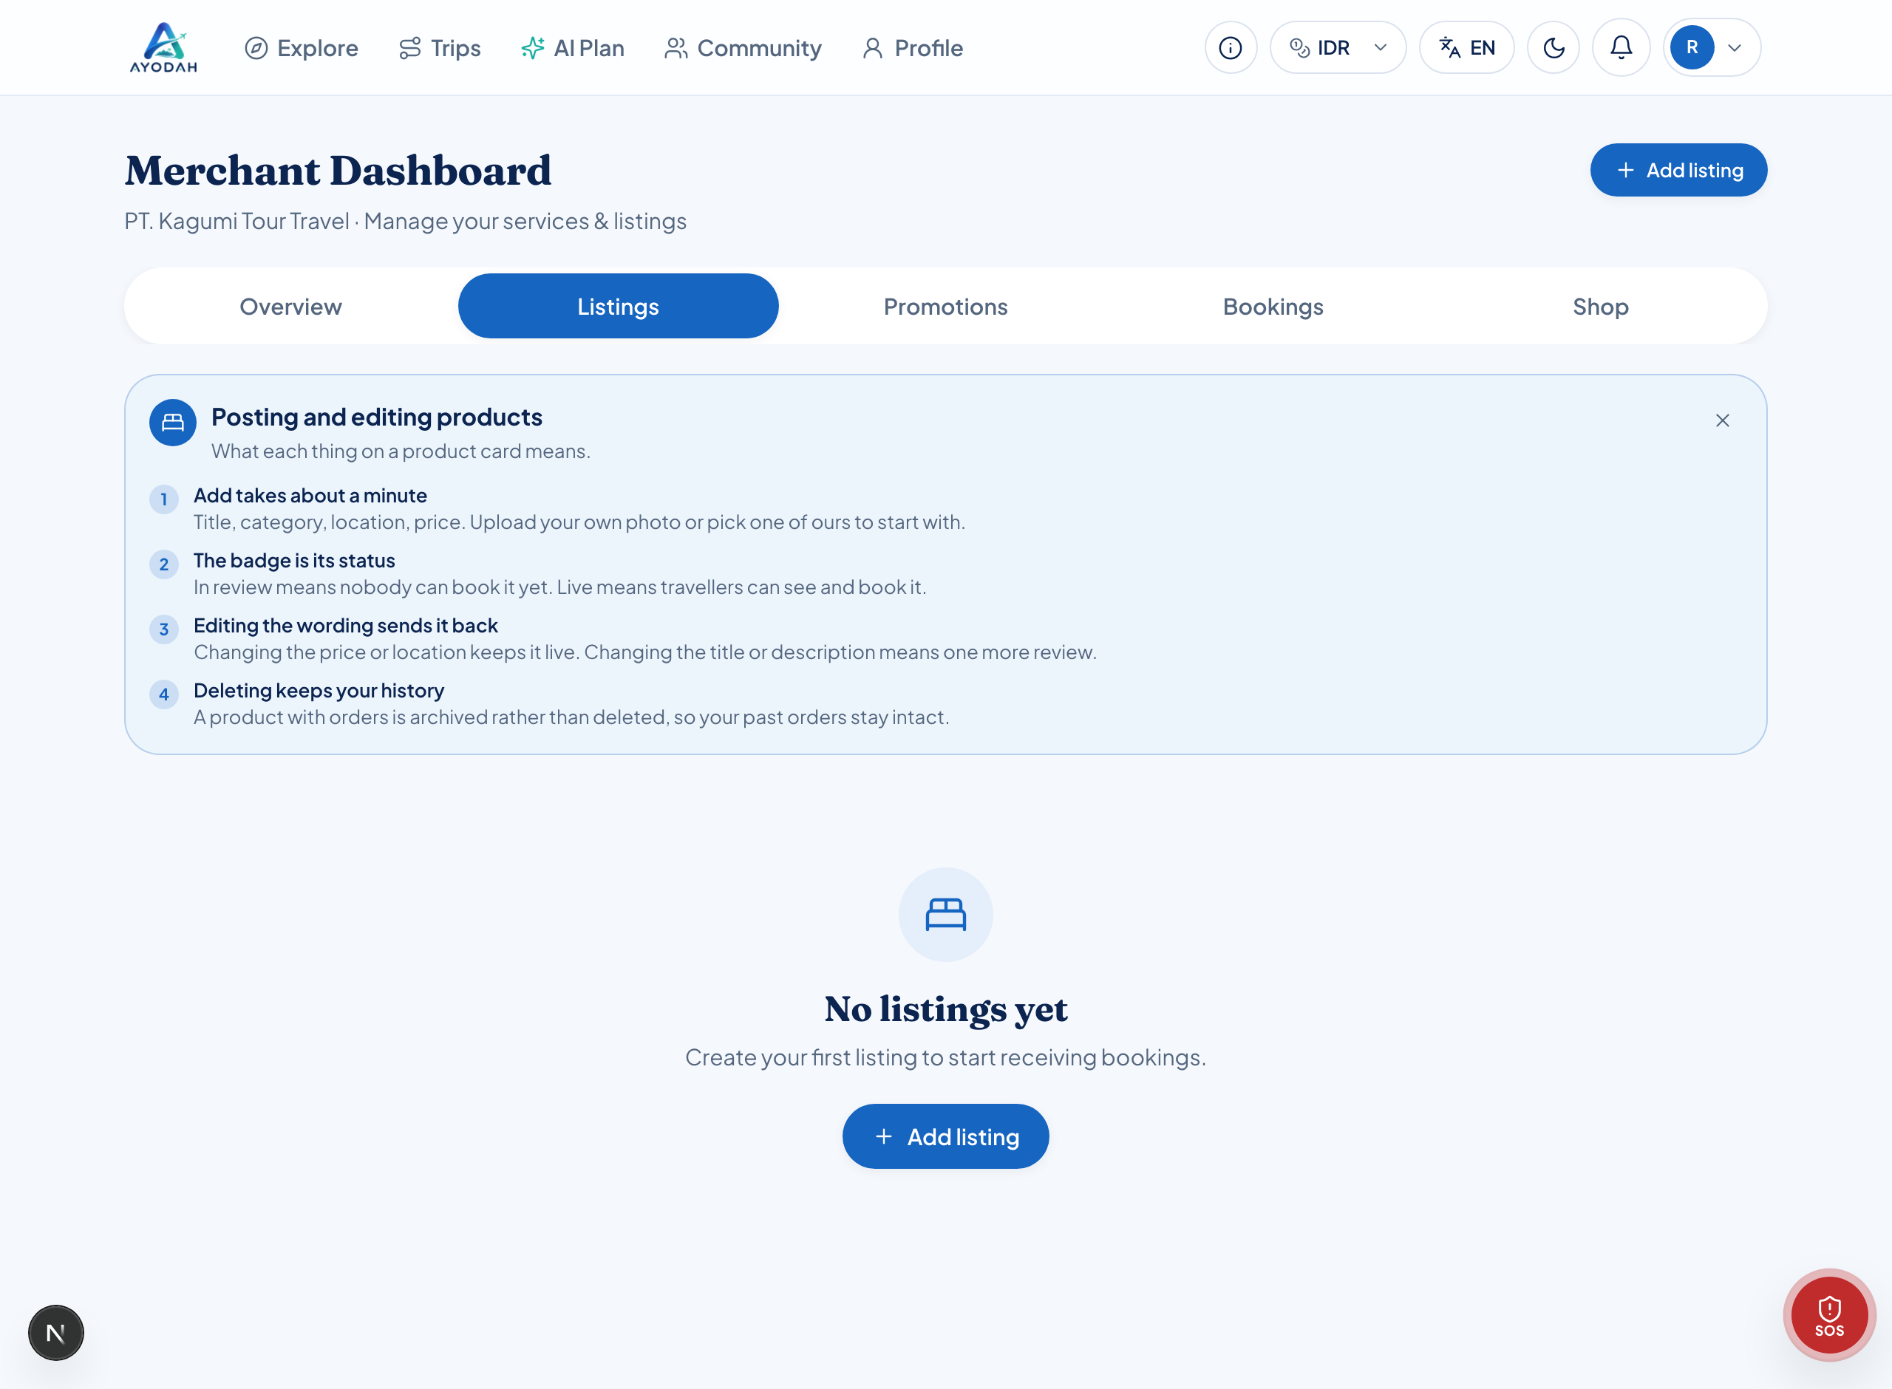
Figure 5 : The Listings tab. The status label sits on each card.
Step 6. Editing or removing a product
- Open the Listings tab.
- Tap the product you want to change.
- Change what you need, then press Save.
- Changing the price or the place: it stays live, and takes effect straight away.
- Changing the title, photos or description: it rejoins the review queue and is briefly hidden.
NOTE
So if you only want to raise the price, change only the price. Do not also rewrite the title, or your product comes off the catalogue while it waits.

IMPORTANT
Deleting cannot be undone. If the product has ever been booked we do not delete it, we archive it, so the buyer’s order history stays intact.

Step 7. Taking and completing orders
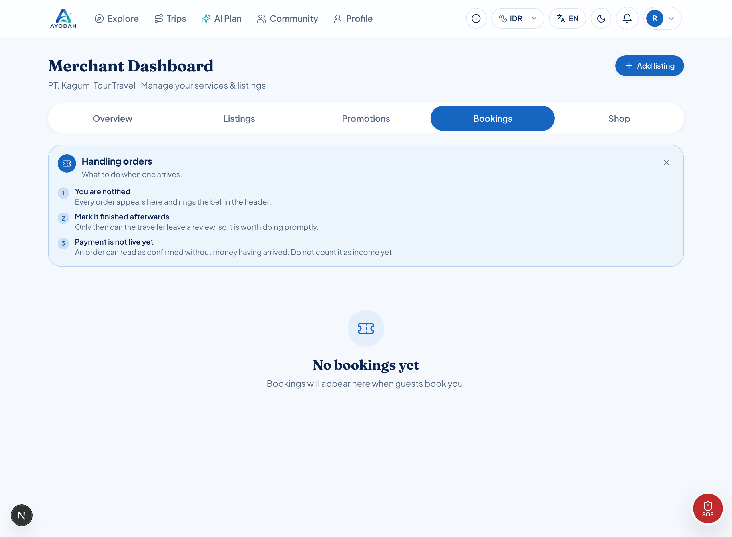
Figure 6 : The Bookings tab. Every order lands here.
- Open the Bookings tab to see what has come in.
- Once the guest has actually turned up and the service is done, press Mark completed.
Marking it matters twice over: the buyer can only leave a review afterwards, and the order only counts as earnings once it is complete.
IMPORTANT
An order can read "confirmed" before any money has arrived. Do not count it as earnings yet, check the payment status first.

Step 8. Cancelling an order, and refunds
Sometimes it cannot go ahead: bad weather, a broken vehicle, illness. You can cancel from the Bookings tab, and you must write a reason, it is sent to the buyer.
IMPORTANT
If you are the one cancelling, the buyer always receives a full refund, whenever it happens. It was not their doing.

If the buyer cancels, how much comes back depends on how close it is to the travel date, counted from the date of travel, not the date of purchase.
When they cancel | Refund
Well before the travel date | In full
Closer to the date | Partial
Very close to the date | None, but they may still cancel

NOTE
The exact windows are set by the AYODAH team and can change. Whatever applies is always shown to the buyer before they confirm.

Step 9. Quoting for something that is not in your catalogue
A traveller may want something your listing does not cover: an extra day, an airport pickup at three in the morning, tickets bought on their behalf, a private car for a group of nine. Before, that conversation moved to WhatsApp and the money left the app with it. It no longer has to.
- The traveller opens your product and presses Ask for a price, describing what they want.
- The request lands in your Quotes tab, with the product and the traveller it came from.
- You reply with an amount and, if it helps, a note explaining what it covers.
- The traveller accepts or declines. Accepting creates a normal order at that price.
State | What it means
Waiting for you | They have asked. Nothing happens until you answer.
Priced | You have quoted. It is theirs to accept or decline.
Accepted | It became an order, and it is in your Bookings tab like any other.
Declined or expired | Nothing was charged. A quote stays valid for a limited number of days.

NOTE
An accepted quote is charged the same way as anything else: the AYODAH service fee and tax are added on top of the amount you quoted. You receive the amount you quoted.

IMPORTANT
Quote inside the app. This is exactly the case that used to push people off-platform, and a traveller who pays you outside AYODAH has no order, no refund route, and no protection if the day goes wrong.

AYODAH fees, what is deducted
This is the most commonly misunderstood part, so please read it slowly.
Line | Example
The price you set | Rp 500,000
AYODAH service fee | + Rp 25,000
Tax | + Rp 55,000
Traveller pays | Rp 580,000
You receive | Rp 500,000

IMPORTANT
The service fee is added ON TOP of your price, not taken out of it. You receive exactly what you set. Do not raise your price to "cover" it, you would only become dearer than your competitors for no reason.

The only thing you pay for directly is Promotion, and that is optional. The current figures always appear on the Overview tab.
Promotion (optional)
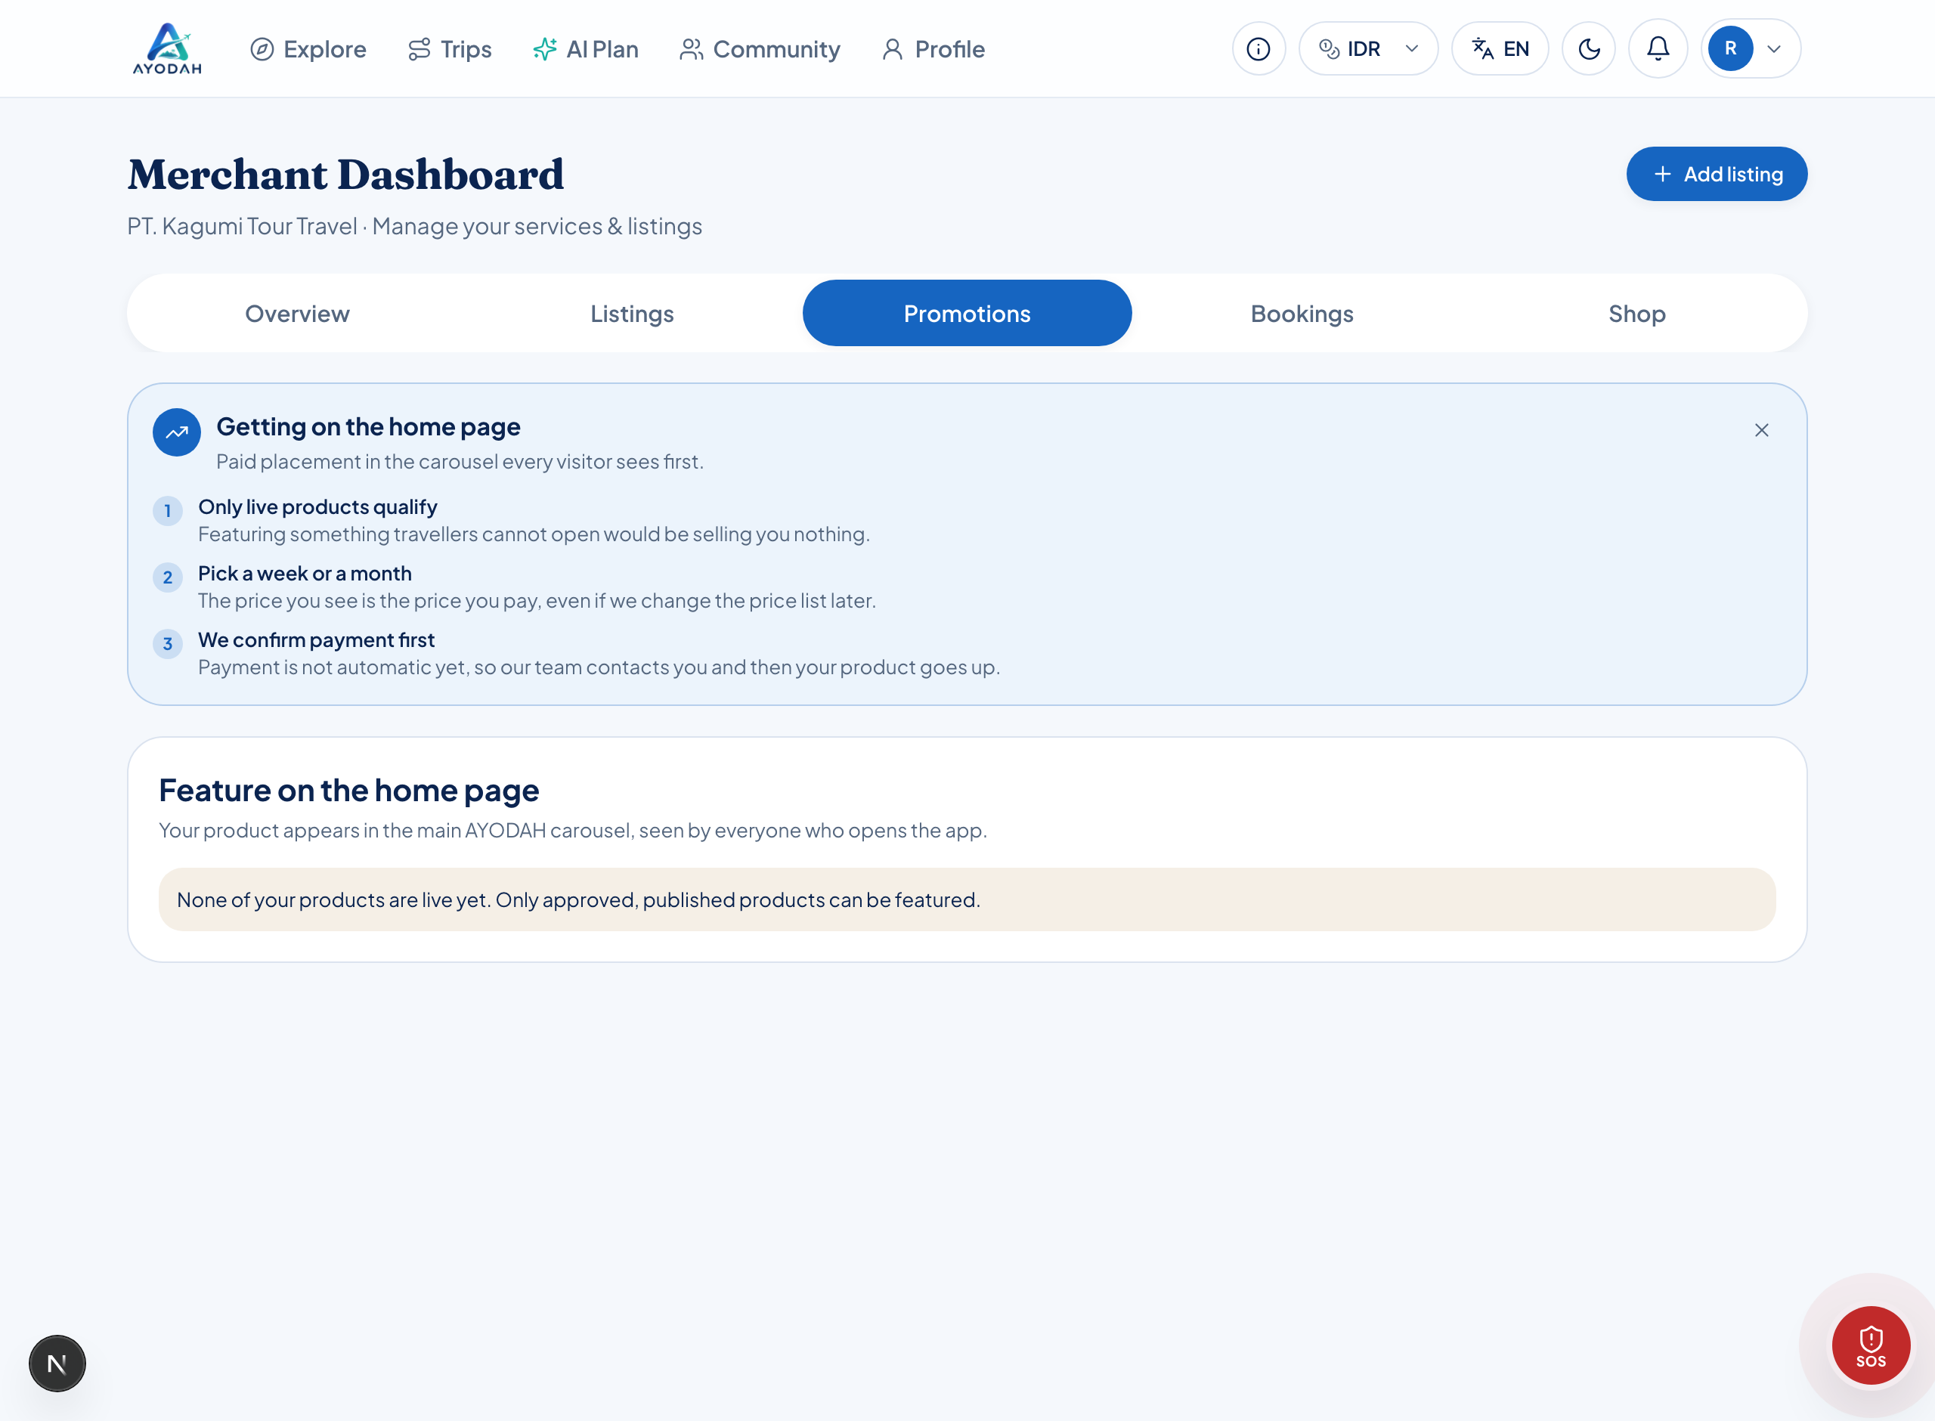
Figure 7 : The Promotions tab. You buy a run of days on the home page.
- Only products that are already Live can be promoted.
- It starts once our team confirms your payment, not the moment you press the button.
- Slots are limited, so the home page stays a shortlist rather than a second catalogue.
Your shop and your account
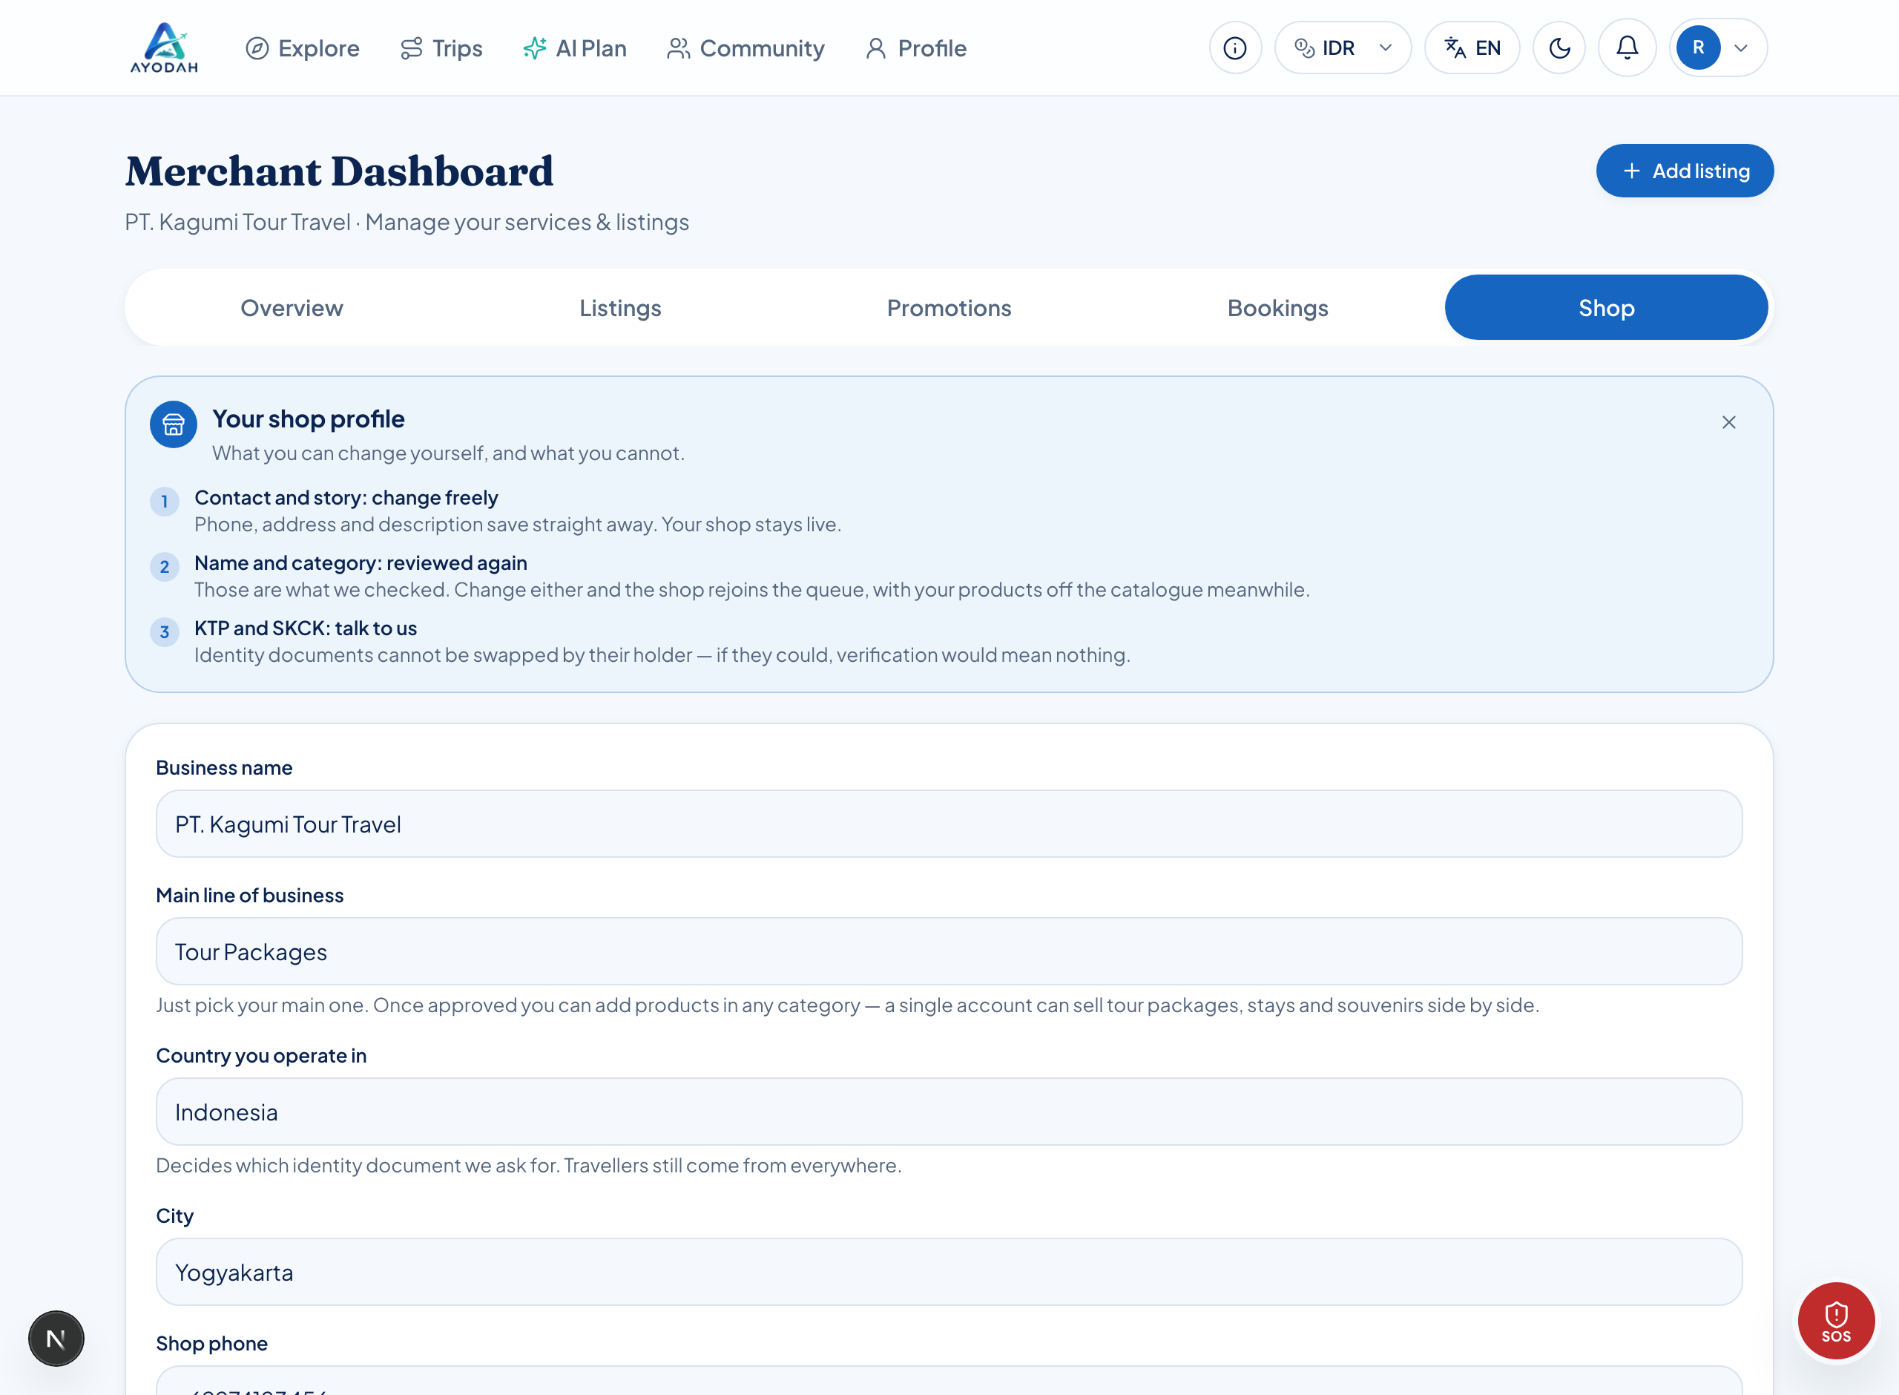
Figure 8 : The Shop tab. Your business details and verification documents.
- Phone, address and description: saved straight away, and your shop stays live.
- Business name, country and category: the shop rejoins review and your products are briefly hidden. The app warns you before you save.
- Identity documents: you cannot change these yourself. If something is wrong, contact our team.
For your own account, name, email, password, and which devices are still signed in, go to Profile → Account & security.
NOTE
Changing your password signs out every other device. That is the point: if you think somebody got in, changing it is how you throw them out.

Talking to your buyers
Every order has its own chat between you and the buyer. Open it from Profile → Messages. You may exchange phone numbers there to arrange a pickup, that is what it is for.
That conversation is private. Not even an admin can read it unless somebody reports a message in it.
NOTE
There is a Translate button on every message, so you can serve foreign guests without speaking their language.

Rules you must know
IMPORTANT
Do not invite buyers to transact outside AYODAH. A WhatsApp number, a link or a bank account in a product description, a review, or the public room is automatically masked as ***, and anybody who keeps trying is reviewed by our team.

This is not merely a rule. A buyer who pays outside the app loses every protection: no order record, no refund route, and if something goes wrong we cannot help either of you. That harms the buyer, and in the end it harms you.
In the order chat with your own buyer, phone numbers are fine. What is never allowed, anywhere, is moving the payment off the platform.
IMPORTANT
Bad language is masked automatically too, in product descriptions, reviews, chat and the community feed.

If you are stuck or something is wrong
- There is a blue guide box at the top of every screen. Read that first.
- If you dismissed it, open Profile → Help to bring them all back.
- Still not answered? Open Profile → Help & complaints, then press Report a problem.
When you report, pick the right category and quote the booking code if you have one (for example AYD-1234). That lets us find it immediately instead of asking first. Our reply arrives in your notifications.
NOTE
Safety reports are always put first. If you are in danger right now, call 112 before anything else.

Checklist before you press Save
☐ Photos ready (several of them, up to 4 MB each)
☐ Title clear and specific, not in all capitals
☐ Category chosen
☐ Place is the venue, City is the city
☐ Price in digits only, no dots
☐ Price unit correct (/person, /night, or /day)
☐ Duration filled in if this is a tour package
☐ Description says what the buyer gets
☐ No phone number, link or bank account in the description
☐ You pressed Save

